Wine tour of the XXI century in Rioja region Spain

Visit Marques de Riscal, Bodega de Ysios & Raphael Lopez de Heredia

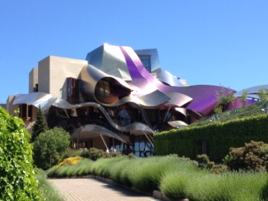 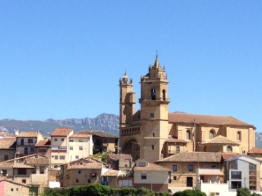 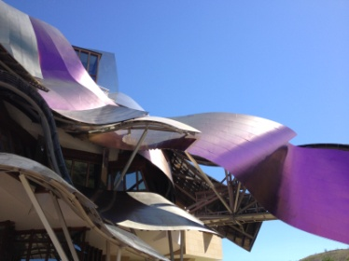 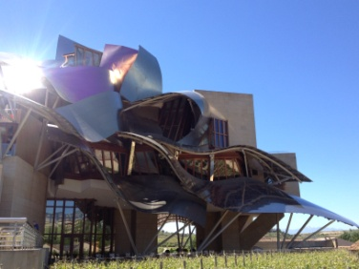 Marques de Riscal by Franck Gehry
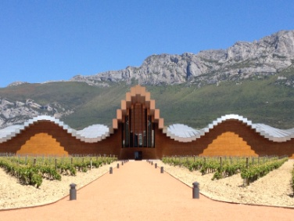 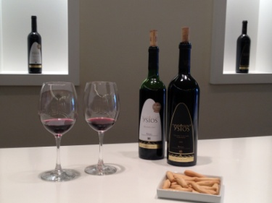 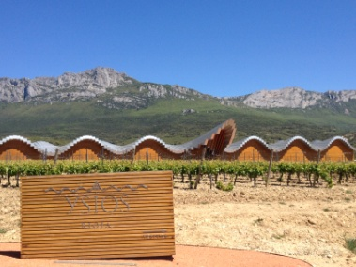 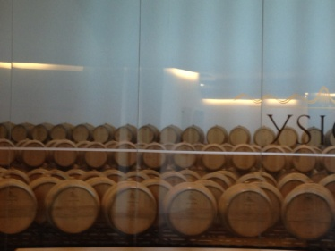 Bodega de Ysios by Santiago Calatrava
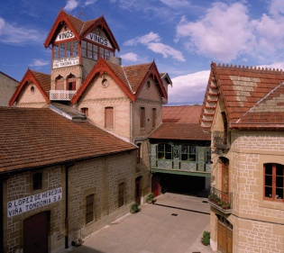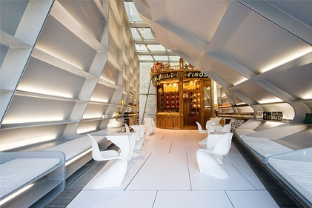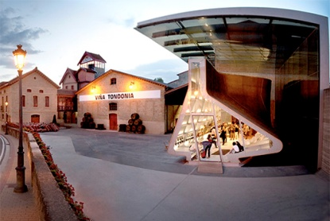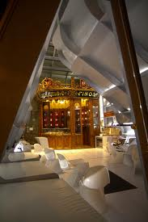
Bodega Lopez de Heredia by Saha Hadid
A day trip in the Rioja region to visit the famous:
Hotel Marques de Riscal, Raphael Lopez de Heredia & the Bodega de Ysios.
10 hours day tour (from 8h30 to 18h30 or at your convenience)

We’ll start by visiting the Bodega Raphael Lopez de Heredia, in Haro, from the famous architect Zaha Hadid. We’ll go for a visit and wine tour of this amazing winery.

We’ll then head to Elciego, where Franck Gehry, Architect of the Guggenheim Museum has built this breath taking hotel Marques de Riscal. We’ll be able to stop a drink or for a lunch.. All up to you..

We’ll then head to Laguardia, to see and visit the Bodega de Ysios, it will take about an hour and half to make the tour.. and about 30 minutes to admire this amazing Bodega built by Santiago Calatrava.

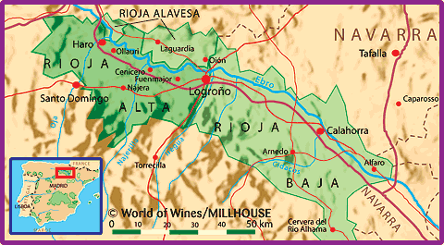
We can adapt your tour and visits tour depending on your wishes, and on the timing.
Additional hour 50 €.

Wine tours are around 10 to 12 € each per person, are not included in the price. Lunch is not included
We need to make reservation to be able to visit the wineries at least 24 hours before going.

Entrance and wine tasting cost, food are not included in the price

